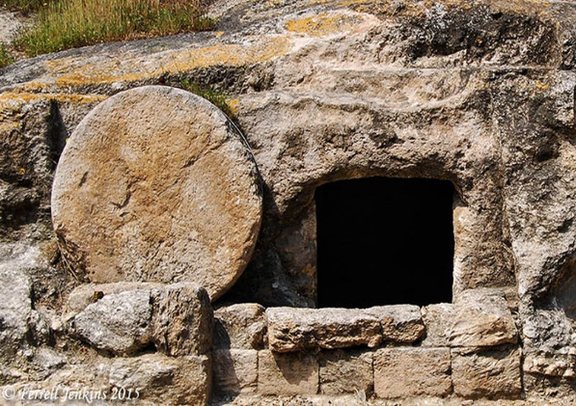
Jesus and Mary Magdalene

John 20 v 10 to 18

The unpredictable surprise – but was it? You can go right back to Caesarea Philippi where, after Peter’s confession of Christ, Jesus tells the 12 that he will die and ‘rise again after 3 days’ (Mark 8:31) The next verse says ‘he spoke plainly about this’. Peter even told Jesus off about it which was when Jesus said ‘Get behind me Satan – you do not have in mind the things of God’. So, the idea of Jesus’ resurrection had been spoken about – actually on several occasions. With the benefit of hindsight, you might say the disciples were all a bit on the slow side having been told by the Son of God that he would rise.
FROM THE PASSAGE
If your group wants to go through the verses, here are some questions to guide you
- Mary was left alone (v10 & 11). Not someone who apparently played a key role in the new church of Jesus Christ. Yet she is the one who gets to see the angels in the tomb. Surprising?
- She is at the first and most profound moment of meeting the resurrected Jesus. She is hardly in the apostolic ‘inner circle’ but she sees angels and she meets the risen Christ. Surely it should have been the key figures who should get to see Jesus first. So why Mary?
- ‘Crying’ is a key aspect of this encounter. John records it as Mary is left by the tomb. The angels challenge her behaviour and so does the risen Jesus. Is it just that Mary has lost someone very dear or does she think that the mission of Jesus has just crumbled? Was she even doubting the salvation that Jesus had offered her was no longer valid?
- Her response to the angels in v13 says ‘they have taken my Lord away’. What’s more she says she doesn’t know where ‘they have laid him’. She is assuming he still needs laying somewhere so she thinks he is still dead. Even an empty tomb and 2 angels doesn’t appear to raise questions about something that Jesus had taught them. Many Jewish groups believed in bodily resurrection. What blinded Mary to this possibility?
- Mary’s lack of recognition of the risen Jesus raises at least two questions. Was he so different to the ‘earthly’ Jesus that she had been with or was she so emotional that her mind was just not thinking straight?
- Jesus speaking Mary’s name was enough for her eyes to be opened. She had thought that the man who stood before her had moved the body. Her mind was still on the tomb – not on the man before her. The reality of meeting Jesus is far more important than why the tomb is empty. She wanted closure on where her Jesus was and Jesus lifts her to another level by speaking her name.
- Once recognition has occurred Mary wants to go back to how it was. ‘Do not hold me’ implies that she had embraced Jesus. She uses the very familiar ‘Rabboni’ greeting which she had probably said many times before. Why does Mary want to take Jesus back to pre-Calvary days?
- Jesus’ statement in verse 17 has often been difficult to interpret. He says he has not yet ascended to the Father but instructs Mary to return to the disciples and tell them that he is going to return to His Father. Perhaps it is enough to SEE the Lord. That’s what Mary says to the groups when she returns to them. Jesus’ ministry is nearly complete. All that remains is his return to his Father and the coming of the Holy Spirit at Pentecost.
THINGS TO DO
It’s easy to read a narrative like this and simply close the Bible in awe and wonder and do nothing. Here are a few things you might like to consider.
- Take time to read some of Jesus’ teaching in the gospels and realise the enormous breadth of his teaching. As you read ask God to broaden your understanding of Jesus’ words
- Spend time reflecting on the person of Jesus and remember the time he called YOU by name.
- Ask God to show you the person you could share the Good News with that Jesus
- Search the internet for ‘evidence for the resurrection’ and make sure you could tell that to someone who asks.
SOMETHING TO THINK ABOUT
As you go about the business of the week think about
Jesus spoke to Mary
He called her by name
Jesus speaks to me
He calls me by name
HELP ME ALWAYS TO HEAR GOD’S VOICE
WHERE DO I GO TO LISTEN?

