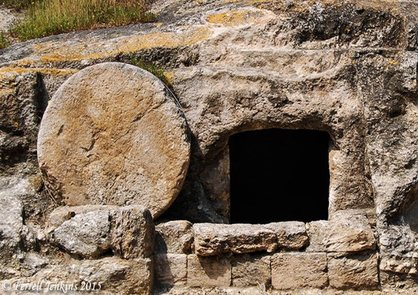
‘Peace be with you’

John 20 v 19 to 31

FROM THE PASSAGE
The parallel account in Luke describes how the followers of Jesus did not return immediately to Galilee. Jesus appears to them and they are frightened and doubts and fears were dispelled only when Jesus provided evidence for them by displaying his wounds and eating a meal. Both give the disciples clarity that Jesus is a ‘bodily’ resurrection. He is not a ghost. It’s still the day the disciples were first at the tomb but fear still appears to hold them back.
Jesus greets them with a standard Hebrew greeting – ‘Peace be with you’. Peace is not just freedom from stress – peace is a gift from the Kingdom of God. It’s what the Jewish nation had longed for ever since they settled the land. So, this is far more than a greeting – Jesus is summing up his work. This is the presence he brings and, now he has been raised from the dead, Jesus has delivered His peace to them.
Jesus’ appearance is clearly unexpected. The doors are shut and fear has gripped the disciples. They probably thought that their fate would be the same as Jesus had suffered. This appearance is clearly miraculous as the ‘doors are shut tight’ (v19). Jesus’ final task is to commission his followers.
- Why were the disciples afraid and hiding behind locked doors? Earlier in the day some of them had witnessed the empty tomb.
Why were this group so fearful?
- Jesus showed them the evidence that his body had been scarred (v20). This is convincing enough to those 1st century eye witnesses.
Do we sometimes demand more proof than we need to be sure that Jesus rose from the dead?
- The disciples needed physical evidence to believe it was Jesus. They saw his wounds and believed. Once they see Jesus in the room the disciples are filled with joy.
Do we sometimes stay too long in the ‘disbelief zone’ when we have the evidence before us? How much more proof do we want that Jesus rose from the dead?
- This is not just a cosy post-resurrection meeting with Jesus. It comes with a challenge that is repeated in different forms in every gospel account. Jesus says ‘I am sending you’ (v21).
How should we interpret this statement?
- Jesus specifically gifts his disciples with the Holy Spirit and this is before the Day of Pentecost. Now this is the gift God gives to all believers.
How does this change how we approach our friends and family with the good news of Jesus?
It’s almost as if Jesus knew that, down the ages, there would be ‘resurrection doubters’. He is leaving evidence scattered all over the place so that, together, all these meetings make up a convincing case that Jesus, who once was dead, is now alive again. The incident with Thomas is significant because Jesus records that there were even doubters amongst those first century eye witnesses.
Thomas had been absent for the Easter Day meeting in Ch 20:19 to 23. He is a ‘modern man’ and he demands to see evidence and Jesus graciously shows this doubter the prints of his nails. He believes and confesses. It is worth noting that a week later the disciples are still locked up in their ‘bunker’.
- Thomas has seen the evidence and he doesn’t need to touch. He makes the connection back to the cross which gave Jesus his scars and he believes.
Should we present the resurrection event to our friends and families with the well documented evidence of the gospel account?
- Thomas is commanded by Jesus to ‘stop doubting and believe’ (v27).
Why do our doubts crop up from time to time?
Is it that we haven’t looked at the evidence?
Is it that the resurrection is hard to believe?
What causes doubts for you and how can you deal with them?
THINGS TO DO
Take a look at the post-resurrection appearances in all the four gospels and the beginning of Acts.
- The New Testament is a valid historical document so make a list of all the people who saw the risen Jesus.
- Have you been a ‘doubting Thomas’? When do your doubts occur and over what issues? Read the resurrection stories again and ask God to give you the assurance that what you have read is both reliable and true.
- Take some time to think about the two meetings in today’s passage. Who would you identify most within the first gathering and do you have some sympathy for Thomas?
SOMETHING TO THINK ABOUT
During this week think about the people you normally meet in your daily life and reflect how many of them have either no knowledge of the resurrection story or regard it as a fairy story.
Pray that you might have opportunities to share the truth of the resurrection with friends and family
He calls me by name
HELP ME ALWAYS TO HEAR GOD’S VOICE as Thomas did

