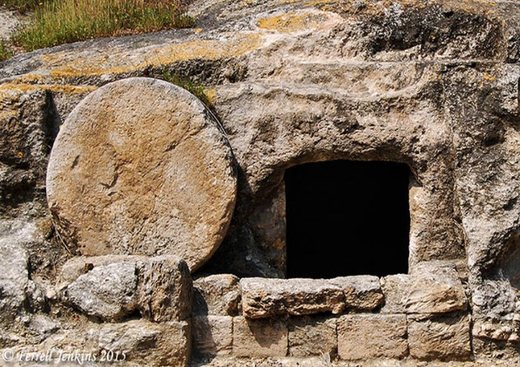
Gone fishing

John 21 v 1 to 14

BACKGROUND
We are back in Galilee where it all started. John and Luke have recorded resurrection appearances in Jerusalem. Matthew and Mark record the words of an angel (Mt 28:7 & Mark 16:7)
‘Go and tell his disciples and Peter. ‘He is going ahead of you into Galilee. There you will see him just as he told you’’
The disciples have been told to return to the ‘base camp’ they used during the three years of Jesus’ ministry. John records the Easter Sunday appearance, then a second time around a week later and now this occasion by the lake. John 21:14 tidies that up when he records there have been three appearances.

The Sea of Tiberius (Galilee) is around 75 miles north of Jerusalem, surrounded by hills. There are numerous fishing villages on its shoreline. Peter comes from these parts. So, the beginning of John 21 finds Peter back home having returned to his pre-Jesus occupation. Other disciples are there even though this is not their home area. (e.g Nathanael from Cana). The seven listed in 21:2 join Peter for a night’s fishing. The best fishing is usually done in the early hours before sunrise. Families usually worked together in pairs using large nets that would encircle a school of fish. Then the fisherman would ‘cast nets’ over the encircled catch and draw them into a boat or sometimes a swimmer would drag them to the shore. Jumping into the water was part of Peter’s daily work routine.

FROM THE PASSAGE
After the trauma of Jerusalem, Galilee would have felt like a breath of fresh air. People visiting Israel today often say that the ‘fair green hills of Galilee’ are a real tonic after the phrenetic streets of Jerusalem.

- After the events of the Easter weekend, they have come to a more relaxed environment. They have witnessed the resurrection and have received the Spirit. One question remains – what will they now do with it?
Have there been times where you have experienced a watershed moment where you have to decide how you will move forward with God?
- They have tried to do something very familiar (at least to some of them) and it’s been a dismal failure.
How do you cope when you have tried to serve God and it just hasn’t worked out?
- The miraculous catch of fish is both a surprise and a symbol. After very poor overnight results suddenly the fish have re-appeared. This is another picture of growth in the hands of a leader who takes the action God demands (cf Shepherds and sheep)
Peter was a professional fisherman – the man on the shore was ‘unknown’
Do we find it hard to take God’s leading in an area where we think we have competence?
- Peter’s previous history wasn’t great. His attack in the garden was followed by his triple denial which resulted in bitter weeping. Now he is a failed fisherman only put right by a ‘stranger’. Peter could have become a man filled with despair. Jesus had seen his many weaknesses – he could have gone into deep self-criticism and despair.
But he didn’t – he became a key figure in the life of the early church. His writing and leadership were vital in its development.
How do we best recover from times when we know we have failed or let God down?

- Jesus clearly had different plans for his impetuous disciple. Peter ran to the only person who could heal his memories and rewrite the sights and sounds of his recent past. The work of God in our lives can only go forward when we ask God to heal destructive memories. It is surely no accident that the disciples on the shore gathered around a charcoal fire just as Peter had denied Jesus in precisely the same situation.
How good are we at allowing God to heal our memories of failure?
- The intimacy of this gathering is striking. Nobody dared ask ‘who are you?’ – they knew it was Jesus. How unforgettable it must have been when Jesus took bread and gave it to them. They would have seen his scarred hands and the memories of the upper room would have flooded back.
Are there times when we (figuratively) need to sit down with Jesus and know that he is with us? Do we particularly need to do this at times like the present?

THINGS TO DO
There is much here about the restoration of relationship. Perhaps we need to
- Ask God to give us the assurance that we are his children despite our failings or denials.
- Ask God for his forgiveness for the times we have failed
- Ask God to help us trust him more when he speaks to us
- Learn to enjoy again the times we spend with God

SOMETHING TO THINK ABOUT THIS WEEK
As you go about the business of the week think about
Peter tried to kill a man in the Garden
Peter denied he ever knew Jesus
Peter had tried to tell Jesus he was not to go to the Cross
JESUS said – come and sit down and eat with me (the ultimate expression of fellowship and intimacy)
How full of love and grace is our Saviour and Lord
HELP ME ALWAYS TO HEAR GOD’S VOICE IN HIS WORD

