Signs of the end – Matthew 24 v 1 to 14
This Sunday our study is based on the lectionary reading for the day and follows on from the sermon preached at the 9.00 service. We have a very special passage of scripture. Jesus and others often spoke of his return and what would happen when he came. There is far more in scripture about his second coming than about his first coming so it is an event we should take seriously.
We are in the last earthly week of Jesus’ life. The whirlwind of Holy Week must have stretched the disciples. Jesus had spoken about his death but the band of 12 were probably hoping it would never come to that – Jesus would find a way out; he always did. The triumphal acclaim of Palm Sunday had been replaced by constant pressure after Jesus wrecked the temple’s money changing tables.
The religious leaders in Jerusalem are out to get Jesus – the disciples must see that following Jesus is going to get dangerous. Jesus urgently turns to his disciples to prepare them for what’s to come. For the fifth and final time in Matthew’s gospel, he launches into a major discourse. This one is prophecy about the catastrophe that awaits the nation and the events that precede his return.
- How would you sum up how the disciples are feeling on the Tuesday before Good Friday?
Where do you turn when faced with pressure?
After the theological debates with the religious leaders, Jesus and the disciples leave the temple and the city to go to Bethany where they stay each evening (21:17). The road from Jerusalem to Bethany first climbs the Mount of Olives giving a superb view of Temple Mount.
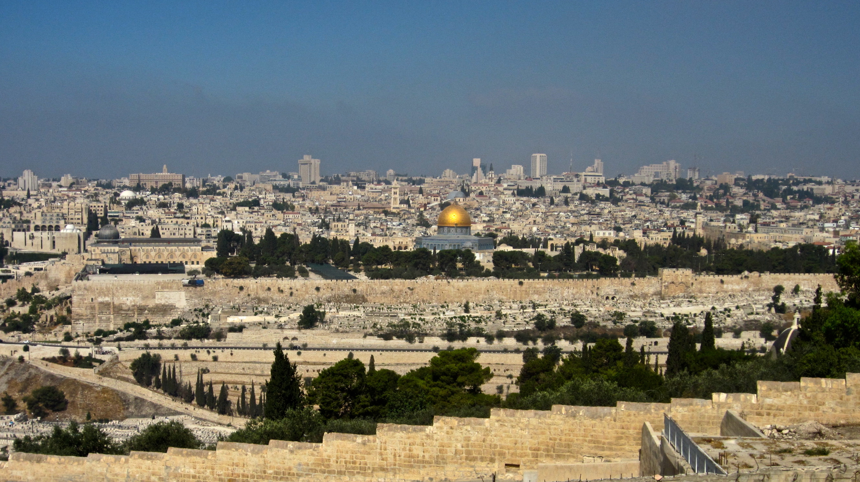
The site of the temple was where you see the mosque with the gold roof. Where the picture was taken is close to the site where the disciples would have drawn Jesus’ attention to the buildings (v1 & 2).
- Jesus’ statement about the destruction of the temple is shocking. This had been the centre of Jewish worship for 100’s of years.
What was Jesus communicating when he spoke about the temple?
Why would the disciples have found this so difficult?
The temple was destroyed in AD 70. Jesus sits on the Mount of Olives with his disciples (‘seated sayings’ were always a sign that the teacher demanded attention from his hearers) and he painted a dark picture of the future. This is Jesus’ response to the disciples’ question
‘When will this happen and what will be the sign of the end of the age’. (v3)
- How seriously do we take the idea of the ‘end of the age’?
Do we look forward to the return of Christ?
How does it affect the way we live?
The emphasis in verses 4 to 8 is very much on pain and suffering. Jesus talks about false messiahs, wars and calamities and birth pains (an image often used in the Bible to depict horrible human suffering of all kinds). Not much good news but notice that Jesus says ‘do not be alarmed’. The OT linked wars, earthquakes, famines and other catastrophic events with the end of the age but Jesus is saying that such events will be a regular part of suffering in this life until Jesus returns.
- How do you respond to the idea that catastrophic events are part of life until Jesus returns?
Do such events create anxiety or even anger? Should they?
Do we accept that suffering will be part of life until the return of Christ?
In verse 9 to 14, Jesus moves on to the fate of his own disciples. His clearly states that his followers will face persecution and it will be ‘because of me’ – literally ‘because of my name’(v9). He even says some will be put to death. He warns that some will turn away from their faith and become betrayers – that is, they will become enemies of Jesus.
- We are largely free from overt persecution in the UK. What form does it take in our country and how should it be dealt with?
Talk about places in other nations where persecution is a major factor in living as a Christian? How can we support our sisters and brothers in these situations?
Our response to persecution and the lovelessness of verse 12 should be that we should ‘stand firm’ (v13). But that can be hard. As wickedness grows, we are to do our best, with the help of God, to stand for the truth of the gospel. We should never pin our hopes on the fact that the world will one day get better – it won’t. But we should do our best, within our networks, to keep the name of Jesus in the minds of the people we meet.
- How much of a struggle do you have with the world that surrounds you?
How do the events in the Middle East connect with Jesus’ words?
How should we pray for all the parties involved in the conflict?

