The Transfiguration – Luke 9 v 28 to 36
This Sunday is a one-off Sunday so these notes are connected to the sermon which was preached at the 9:00 service. We have a very special passage of scripture. The Transfiguration is one of two incidents where ‘heaven’ speaks directly about Jesus. The voice that tells the disciples to hear Jesus recalls the voice of God at Jesus’ baptism where the listeners are told very clearly that Jesus is God’s son.
But here there is the authoritative presence of two of the great leaders from the past. The visible glorification of Jesus is also unique – even in his resurrection appearances he is not described as having the ‘brightness’ he has here. It is worth looking at the previous section where Jesus has told his disciples that following him will demand a radical change of perspective.
- Read Luke 9 v 23 to 27. What does it mean to follow Jesus today?
- What does it mean to deny yourself and take up the cross daily? (v23)
- What does Jesus mean by ‘he who loses his life will save it’ (v24)
- What does ‘gain the whole world and lose your very self’ look like in the 21st century?
- Have we ever been ‘ashamed of his words’?
Are Jesus’ demands too hard to follow in a world where allegiance to one faith is hard?
Having made these clear statements about following him, this mountain scene follows on ‘eight days later’. The life of the disciple is different from that of the world. This scene emphasises the need to listen to Jesus. If you read the rest of Luke 9, you see that the disciples’ reactions to many situations needs a re-think (see Luke 9:46ff). They will need to listen carefully and correct their ways.
- Is it easy to think that we know the sayings of Jesus (or we think we do?) and we need to go back and read them again.
Are there particular sayings of Jesus you have found a challenge? (For example, the ones we looked at in Luke 9:23ff)
Are there dangers in ‘watering down’ Jesus’ words – we might say ‘that doesn’t apply to us’.

Mount Tabor is the traditional site of the Transfiguration.

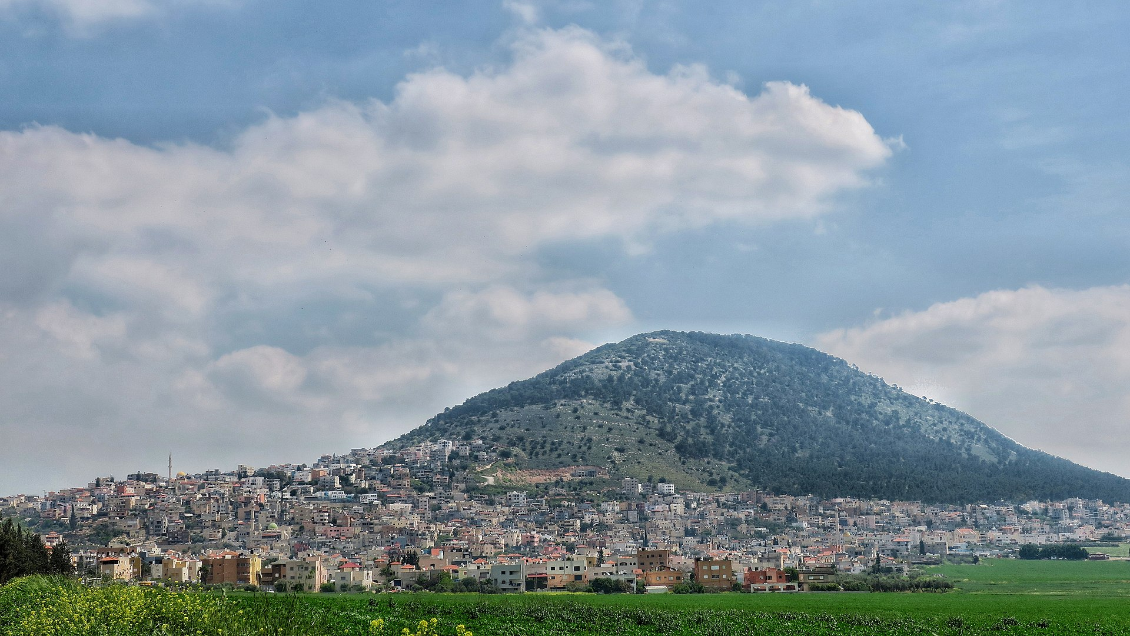
It is in southern Galilee quite close to Nazareth. The fact that the mountain is not given a name in the passage would suggest it is unimportant.

If ever you visit Israel the ride to the top in a Tabor Taxi is the white-knuckle ride of the century.

During his time of prayer, Jesus is transformed into a glorious figure with a brilliance like lightning. It is similar to what happened to Moses (Exodus 34:29 to 34). The two who appear with Jesus represent two key parts of Israel’s history. Moses speaks of the kind of prophetic leadership Jesus fulfils to perfection and Elijah lived in the time of looking forward to the coming of the Messiah. Standing with him tells us that Jesus is the fulfilment of OT hope.

- Are there dangers that we reduce Jesus to a ‘lovely friend’ (which he is) and miss the fact that he is glorious Son of God? Is he too matey to be mighty in our thinking and attitudes?
- Do we miss the fact that Jesus of the everyday is the Eternal Son of the Father who has been ‘from the foundation’ of the world?
Moses and Elijah are discussing Jesus’ departure. Luke is the only gospel to note the topic of conversation. They talked about bringing ‘fulfilment to Jerusalem’. They are talking about the clear plan that Jesus must die in Jerusalem and much of the rest of Luke’s gospel from chapters 9 to 19 is about preparing the disciples for ministry in the light of his departure.
- Jesus’ departure forms a major part of the gospel narrative. They found it very difficult to grasp. Is our relationship with Jesus based more on his actions on earth rather than on his atoning sacrifice to deal with sin. In other words, is the cross important enough to us?
The disciples wake up to find the discussion in progress. Peter is so excited he wants to build booths which connects with the Feast of Tabernacles which looked forward to the arrival of the end times through recalling God’s provision for his people during the Exodus. Peter understands that Moses and Elijah represent hope for the nation. Peter wants three equal booths which prompts Luke to comment that he doesn’t know what he’s saying. The ‘booths’ idea vanishes as a cloud envelopes the three of them. The disciples are filled with fear but the voice from heaven is significant.
- There are three elements to the heavenly statement
- My son
- The chosen one (elaborates on ‘the one I love’ heard at his baptism).
- Who must be heard
How important are each of these elements? How important is it that he was ‘chosen’? etc …….
There is no need for booths – they need only listen to his voice. After the event they are startled and they have a lot to think about. But in 2 Peter 1 v16 to 18 you can read Peter’s more measured reflection on an event that left its mark on him.
- Do we realise the privilege of hearing the voice of Jesus?
Do we understate the glory of Jesus?
Do we value the fact that we can talk to Jesus?
In what ways do we need to change our view of Jesus?

