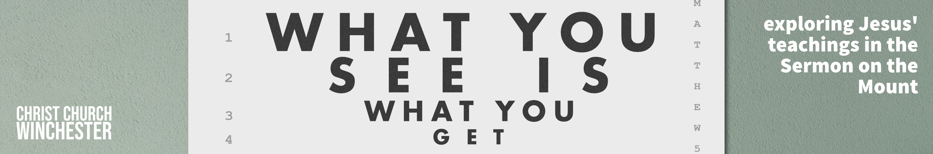
No 10 Eyes on the prize Matthew 6:5 to 15
Jesus is giving his disciples teaching that will help them understand their place in his kingdom and in their world. This section on prayer is closely linked to the previous four verses about giving. Together they give us a picture of how believers should conduct themselves as they go about their business. In a 1st century context pious Jews prayed publicly at set times. There were morning, afternoon and evening prayers (Daniel 6:10, Psalm 55:17 and Acts 3:1)

- We could perhaps broaden the scope of this issue and ask whether it is possible for us to do any kind of service that gains the attention of others?
How easy is to crave attention and want to be praised?

In contrast to the public exhibitionist in prayer, Jesus encourages his followers to ‘go into their room and close the door’. Most people in Jesus’ day did not have private quarters in their homes so this is most likely a metaphor to encourage privacy wherever you can get it. Most of us would have a room with a door so we could follow Jesus’ instructions very easily.

- How do we apply this in our 21st century context?
Does it matter where we pray?
Jesus is not saying we should not pray in a public place with others – do we do that enough?
Are we sometimes too reluctant to pray with others?

At the core of this teaching is the attitude of the heart. Wherever we pray our focus is on God – after all, prayer is defined as talking and listening to God. We are to address him as ‘our Father’ which tells us who we are talking to and also we can do it with other people – he is not MY father – he is OUR father. We are also told not to ‘babble like pagans’. ‘Pagans’ in Matthew’s gospel is often synonymous with ‘Gentiles’ – a good example would the people of Ephesus chanting ‘great is Artemis of the Ephesians’ (Acts 19:31)

- Is there ever a danger we will ‘babble’ as we use a lot of prayers very frequently. E.g. the Eucharistic Prayer in the communion service?
Should we take more time over such profound words?
Is there even a danger the Lord’s prayer becomes a babble?

We should not rule out long periods of prayer – ‘many words’ refers to mindless repetition rather than prolonged heartfelt intercession. Having stated the principles, Jesus now lays out an example of how we should pray. It’s a prayer that some of us have said since school days. It is usually called the ‘Lord’s Prayer’ when it should be called the ‘Disciple’s Prayer’ because it is an example for them to follow.

The prayer ranged from big ideas about God to everyday needs and issues. It is unlikely that Jesus intended his disciples to repeat his exact words. These are headlines to point them to things they should be praying for. The phrases in the prayer arise from the issues Jesus has been teaching about. He’s really saying, I have taught you this truth – now pray about it and do it.

- It starts with ‘Our Father in heaven’. Why is this always a good starting point for prayer?
The term used for ‘father’ is ‘Abba’ – a term used by children to express warmth and intimacy.
Is it easy to lose that closeness to God in prayer? Why does it happen?
‘Hallowed be your name’ or ‘let your name be holy’ gives us the right perspective on who we’re praying to. God must be treated with the highest honour. Jews were reluctant to use God’s name. But he is also our friend.
The second petition is for the coming of God’s Kingdom. Jesus inaugurated the Kingdom of God – one day it will be complete and perfect. We should long for that day.

- How do we balance the knowledge of the awesomeness of God with our need for intimacy? Does the idea of a big God sometimes limit our prayers?
How passionate are we about God’s kingdom growing day by day until it is fully consummated?
Do we have the kind of future perspective so that we live and pray ‘until he comes’?

It seems fairly obvious to pray that God’s will is done. But maybe it‘s a bigger idea than we thought. We are really praying that anything stopping God’s purposes being accomplished will be broken down.
When we ask for our ‘daily bread’, we are asking God for our needs not our wants?

- At this present time what should we be praying for in our world so that God’s will can be done – be specific?
How easy is it for our prayers to become a shopping list?
How do we distinguish between ‘needs’ and ‘wants’.

Our prayer for forgiveness should be daily – unless you’ve ever lived a perfect day. But it’s very easy to forget the whole phrase. We are to pray for God’s grace to forgive those who have wronged us (an echo of ‘eye for an eye’)
Likewise the spiritual battle is a daily struggle so we need to pray for God to strengthen us as we seek to live for him.

- As a conclusion to this series why not pray the Lord’s prayer together but pause after each phrase to allow members of the group to add something more specific.

E.G. ‘Give us thus day our daily bread’
Pause (don’t worry if nobody prays but give yourself time to think about the phrase)
Then someone could add - ‘Please help people in Ukraine to have enough food, water and warmth despite Putin’s barbaric behaviour’

