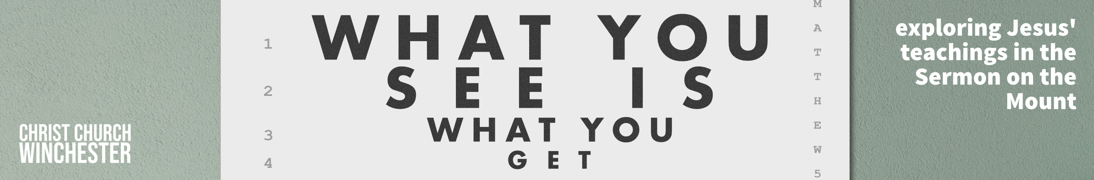
No 11 Fasting Matthew 6:16 to 18
Trust you enjoyed Christmas and are looking forward to another year where God speaks to us from His word. After a ‘foodie’ Christmas, it would be very easy to approach fasting for all the wrong reasons. Primarily it is not here to encourage us to lose weight after, perhaps, eating too much. It is very often linked to prayer so we must approach the topic in a ‘spiritual’ way.

In this short section Jesus is returning to his theme of the hypocrisy of an outward show. Fasting was known as the third pillar of Jewish piety – religious leaders fasted to get recognition from the people. In the first century, fasting took different forms.
- Normal fast – abstain from all food, sold or liquid but not from water for some significant event.
- Partial fast – a partial restriction of diet – e.g. for a three week period of mourning (Dan 10:3)
- Absolute fast – abstain from all food and water to discern God’s leading. (Esther 4:16, Acts 9:9). By necessity this was for a very short period.
- Private and corporate fasts – fasting was normally a private activity but, at times, God’s people came together for public fasts as on the Day of Atonement (Lev 23:37). This was required by OT law. See also Ezra 8:21 to23

- Not every believer practices fasting. It is never laid down as a condition of discipleship but do any of the group have experience of fasting which has helped them?

The expression used in Leviticus for fasting is ‘deny yourselves’ or ‘humble your souls’. It was often a time when the people would put on sackcloth and ashes, go into mourning and spend much time in prayer. (Psalm 35:13, Isaiah 58:3). There were days of national repentance and seeking God’s mercy. Certain days became regular days of fasting (Ezra 8:21, Neh 9:1, Zech 8:19)

- Our present national situation is far from healthy. Is there a case for Christians to come together for a national day of fasting and prayer?

Jesus draws on this history when he speaks about fasting. He assumes disciples will fast because he says ‘when you fast’ (6:16). Giving to the needy along with prayer and fasting were part of first century devotional activity. Jesus does not prohibit fasting nor does he make it a required practice. In confrontations with the Pharisees, he told them that, while Jesus is still around, celebration was more appropriate than fasting. When he was taken away, fasting would resume its importance. (9:14 & 15).

- What does this comparison say about fasting as an activity for us? Is there a balance to be kept between celebration and fasting?

Some people in Jesus’ time practiced fasting twice a week.(usually on Monday or Thursday because Moses was said to have gone up Mt Sinai on those days). They felt they were emulating Moses’ holiness before God. In other words, by fasting, people could make themselves more holy. Jesus is saying that this kind of observance was an attempt by some to make them look more holy than others.

- To look on this as a broader issue, are there ever dangers that we will practice some kind of observance so that others will think we are more holy? Maybe the way we worship or in any kind of behaviour in a church setting?

People would disfigure themselves in order to show they were fasting but not too much so they would still be recognised. Some would sprinkle ashes on their heads. Jesus’ disciples are to have a different approach. Fasting is about our heart for God. ‘When you fast, you are to put oil on your head and wash your face’. This is a social event – it signifies that a person has prepared themselves to enjoy life.

- Read Ecclesiastes 9 v 7 and 8
Rather than making a public display of fasting which destroys any spiritual value, we are to celebrate life while fasting as well as pray with real focus.
How does this change your view of fasting?
Is it something you are more likely to do?

Other people do not need to know about it. Fasting is done within the secrecy of the heart. It can be done in any of the four ways mentioned above. It is never meant to damage your health so don’t go too far. It is there to cultivate a deeper relationship with God.

- Talk about how you might develop your relationship with God in the coming year both as individuals and in your group.

