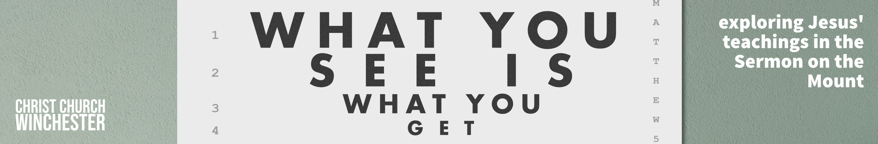
No 13 Don’t worry Matthew 6:25 to 34
Many may remember the song ‘Don’t worry, be happy’. Is this what Jesus is saying? Is worrying about things a sin because we are not trusting God enough? Does it mean we should all be laid back so nothing ever causes us anxiety?
The question to raise is this - if I choose God as my master and Lord and place my value and worth in him, who will take care of my earthly needs? The key phrase of the whole Sermon on the Mount is in this passage
‘Seek first his kingdom and his righteousness’ (6:33)
Jesus speaks very strongly when he says ‘Do not worry’. But we sometimes have a feeling of intense concern for something, such as God’s work (1 Cor 7:32) or a friend’s welfare (Phil 2:20). This would normally be translated ‘Concern’. The same Greek word is used for ‘Worry’ and ‘Concern’ but the context is normally clear which meaning is being expressed. Paul uses the ‘worry’ version of the word when he says ‘do not be anxious about anything …..’ (Phil 4:6)
- What do you worry about?
Are there things in life we should stop worrying about?
Are there issues we should be more concerned about?
Jesus’ next question is asked in a way that demands response.
‘Is not life more important than food and the body more important than clothes?
When Jesus asks a question like that there is only one answer – ‘YES’. The response to the question is that God has given us life in our bodies so it is inconceivable that he won’t give us the means to sustain that life.
- This raises huge questions when we look at the world we live in. How do we respond to the poor and those facing starvation? Do we have a responsibility to work for the fairer distribution of food and clothing?
What is our response to the wasteful society we live in? Is there more we can do?
Jesus then cites the example of God’s care for the created order. Birds use energy in building nests and searching for food. Many of us probably help birds in the cold winter months – in that sense we are part of God’s provision. He then uses a style of argument common in his day (often used by rabbis) known as ‘from the lesser to the greater’ when he says ‘Are you not much more valuable than they?’ Humans are the crown and ruler of God’s creation (Psalm 8 v3 to 8) so their needs will be attended to.
- Have there been times where you felt your needs were not being attended to?
Have you sometimes felt that God has forgotten about you?
Do you think of yourself as the pinnacle of God’s creation – how does that change how we deal with the created world we live in.
Does that mean we have a greater responsibility to care for God’s creation?
Jesus then uses the illustration of clothing comparing the striking robes of King Solomon with a lily. Even today flowers grow around the shores of Galilee with anemones and irises very common. He adds a point about the ‘grass of the field’ which was often used to fire up ovens for baking. In the natural world there is both beauty and provision. Lilies to admire, grass to be used as fuel.
- Those of ‘little faith’ (v30) are condemned because they see the grandeur and pomp of this world as more attractive than the world of beauty and practicality that God has created.
Is that ever a danger for us? Do the riches of the world appear more attractive than they should?
Jesus is keen to emphasise that God knows what we need. So, we are not to worry about what we eat, drink or wear? Pagans ‘run after these things’ (v32) because they don’t have a God who can be trusted. We are often drawn to a quick worldly fix because, it seems to us that God’s provision is too slow.
- When it appears to us that God’s provision for us is late arriving, what lessons is God teaching us in this scenario? Are we likely to challenge God’s timing?
When a need appears to be obvious to us, how do we deal with God’s delay or apparent inaction?
Why do the crops fail in an African drought where people are ravaged by starvation?
Why does God allow a Christian business to fail through lack of money?
The key verse summarises this section and is the big statement of the whole sermon. The disciples are his followers so are already part of the Kingdom Jesus has inaugurated. Seeking the Kingdom is more about trying to do ‘acts of righteousness’ in their daily lives. Jesus statement that ‘all these things will be given you as well’ (v33) implies that the godly life is one in which all of what we do is geared to pleasing God. We don’t have a God bit and a secular bit in our lives – all we do is part of our ‘seeking’ to be kingdom people.
- ‘Therefore, do not worry’ (v34). Kingdom people develop a trust in him so the needs of today will be met – they are all that concern us. ‘Tomorrow will look after itself - each day has enough trouble of its own’ (v34).
Is this too difficult in a modern world where everything is planned in advance?
Can you actually live this way?

Perhaps a good time to pray that we don’t worry about things we should trust God for.

Also pray that God raises our concerns about how his kingdom should be growing in our networks.

What ‘acts of righteousness’ could we start doing?

