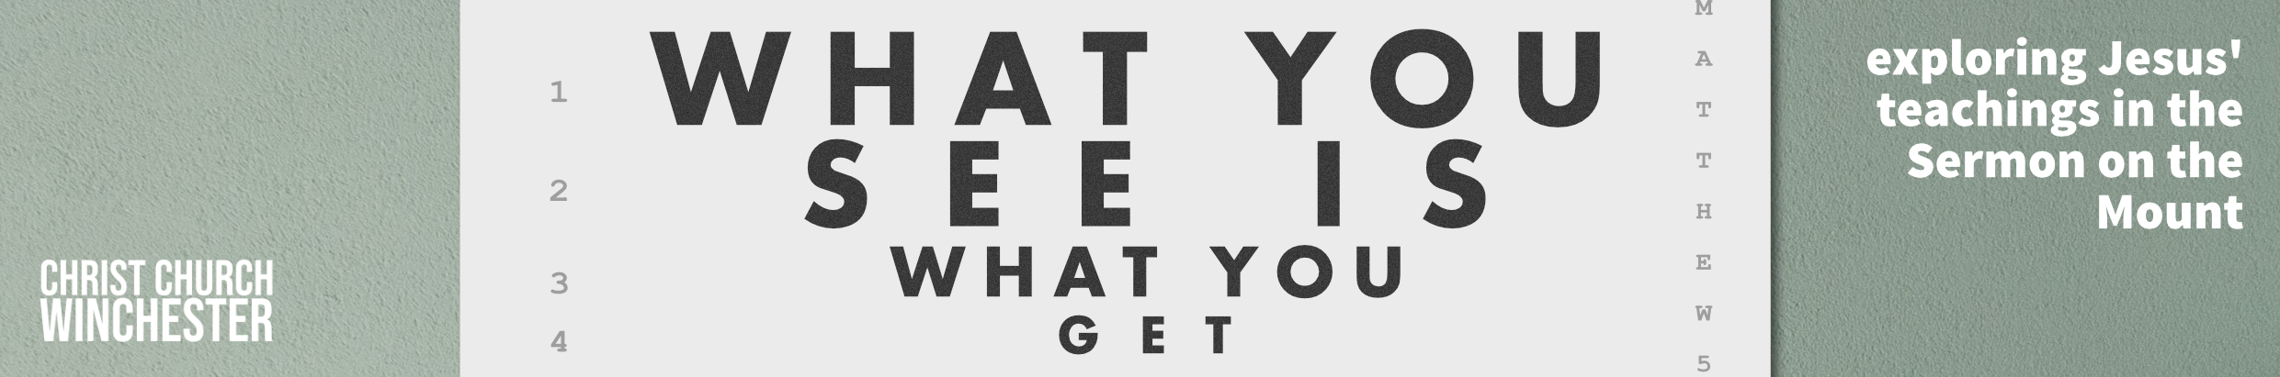
No 15 Ask, seek, knock Matthew 7:7 to 12
There are dangers here as well as blessings. Does it mean that if we ask God for anything we’ll get it? There have been Christians who have said we can have all the wealth we desire - we just have to ask and our generous God will give it to us. That doesn’t sound like it would be good for us – it could easily lead to an acquisitive lifestyle. After all, wouldn’t we all love a brand-new car when we get tired of the old one.
A bit of technical Greek tells us that the three verbs are in the present imperative. That implies constant asking, constant seeking and never stopping your knocks at the door. They are describing persistent prayer. The phrase assumes that our asking, seeking and knocking is done in the context of prayer. It’s certainly not a wish list of all the things we would like.
- When we ask God for something, is it easy to drift towards things we really want rather than asking God what HE THINKS is best for us?
How easy is it to let our prayers become ‘shopping lists’ that we ask God to deliver?
‘Ask, seek knock’ may appear to be unconnected to ‘judging others’ from the previous verses. But Jesus is saying that, if we want to evaluate others wisely, we should approach our Father expecting that we will receive his wisdom on how we see other people.
- How do we arrive at our opinions about other people?
Is God’s wisdom something we seek before we start talking about other people?
Do we think we have a RIGHT to talk about others?
We are faced with some real tensions here, we have to
- Be merciful and forgiving
- Be discerning to give others the benefit of the doubt
- Be on guard for those who are damaging the church or community
- Judge nobody
- Be wise in assessing the true character of other believers.
That’s why we desperately need God’s wisdom. All three words are pictures of prayer. ‘Ask’ is obvious but ‘seek’, in this context, is to seek God’s will and purpose and is a step up from asking. ‘Knock’ increases the urgency to an even higher level. But we should also note the outcomes – ‘it will be given to you’, ‘you will find’ and ‘the door will be opened’. These three give us a clear assurance that prayer brought to the Father will be answered.
- The three words stress the urgency seeking God’s answers in prayer. Do we pray with that urgency – are we aware that we should ‘always pray and not lose heart’ (Luke 18:1)
Share some experiences of where your prayers have clearly been answered and where it appears God has not answered.
Jesus clarifies the idea that God will answer our prayers by two clear analogies which show that God will only give us what is best for us. The staple food of 1st century Palestine included bread and fish. No Jewish father would try to trick his family by offering stones that looked like bread or a snake instead of a fish. The implication is that God will give us what we need on a daily basis. He concludes with a common figure of speech used by the rabbis of the time. If a sinful father (and we all are) would give his kids decent food, how much more will our heavenly father give us exactly what we need.
- How hard is it to accept that God’s answers are always spot on even when we wish for a different answer?
How hard is it to accept the answers ‘no’ or ‘wait’? (Most would say God answers our prayers with ‘yes’, ‘no or ‘wait’).
Some would add a fourth ‘mind your business’ – are there things we do not need to know or things which are too big for us to grasp?
The statement in verse 12 is sometimes called ‘The Golden Rule’ and occurs in the ancient literature of many religions – Judaism, Greek, Roman and later in Hinduism and Buddhism. The Sermon on the Mount is drawing to a close so Jesus takes us to a summative statement on the way of the kingdom. One Roman emperor (Alexander Severus – AD222 to 235) had it written on his wall in gold. The words ‘so in everything’ (v12) means that verse 12 summarises the essence of the Sermon. After these verses Jesus will call on his disciples to be with him or against him (7:13 to 27).
- One commentator explains the Golden Rule as ‘think of a way you would like to be treated then use that as a guideline for how you will treat others’.
How can we get better at that?
Jesus’ teaching here is meant to create stability in his followers. That will happen when we depend on the Father – the one constant in an ever changing world. Also, when we truly live out mutual love as we learn to trust one another just as we have trusted our Father. Jesus’ disciples never have to worry about their needs being met when those will be met in a loving community of disciples.
- How important is it to trust one another? How can we get better at that?
Do you find this teaching too idealistic?
Do we have things to learn about when we turn to God rather than relying on our own wisdom?

You may find it helpful to go back to the start of the Sermon on the Mount and read it through. Reflect on what Jesus is saying about his Kingdom of which we are a part.
Spend some time reflecting on one area where you could get closer to living Jesus’ way.

