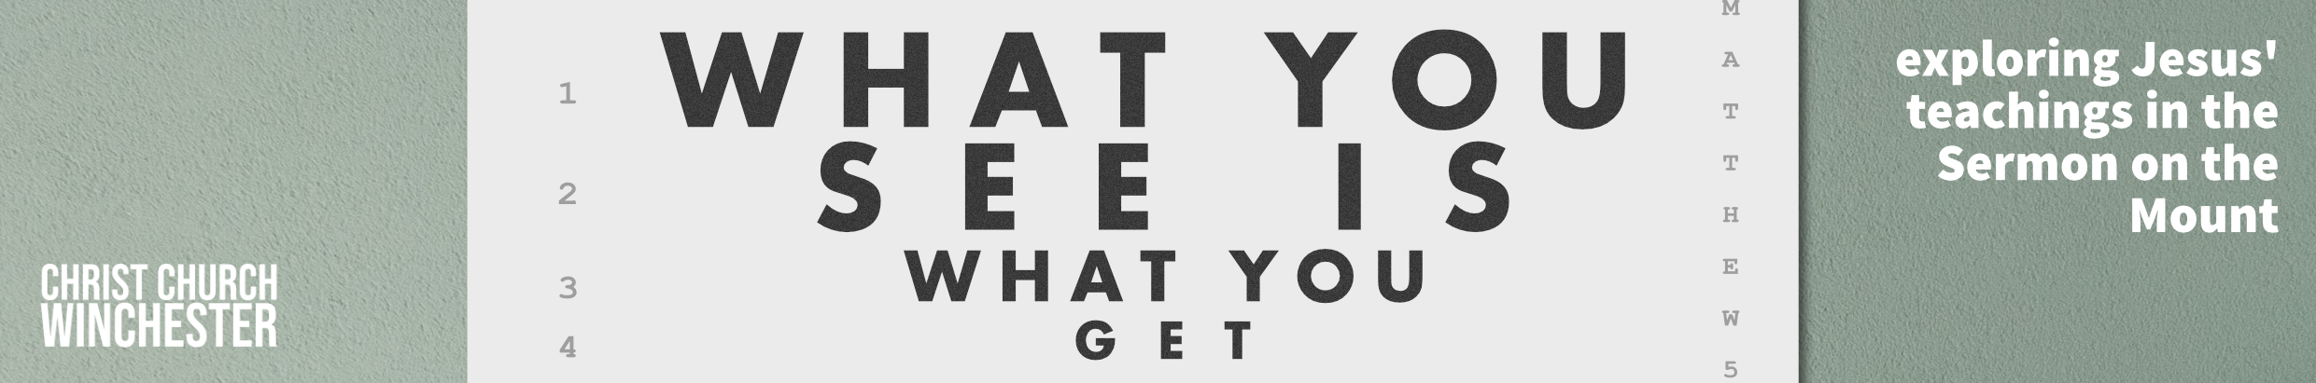
No17 Narrow and wide gates Matthew 7:13 to 14
This idea of narrow and broad gates initiates the final section of the Sermon on the Mount which started in Matthew 5:1. Jesus has extended an invitation to the crowds to enter the kingdom of heaven, and cautioned both his disciples and the crowds about the failures of the religious leaders of his time. Jesus now draws his sermon to a close by addressing all three groups.
He warns his disciples to examine themselves to be sure they are members of the kingdom. He warns the crowds to consider carefully the alternative of following him or the religious establishment. And he warns the religious leaders about their responsibility to lead God’s people in the right direction. In each scenario, two choices are given.
The idea of two paths in life was a familiar idea in 1st century Judaism. They talked about the path to glory or to eternal darkness. Jesus’ use of the imagery is specific and straightforward.
- WIDE GATE leads to BROAD ROAD which leads to DESTRUCTION
- NARROW GATE leads to NARROW ROAD that leads to LIFE
There is no middle way.
- If someone enters the wide gate of Jesus’ imagery in the 21st century what would you expect them to be doing?
What would you expect a narrow gate entrant to be doing?
Is it just about being a good or bad person?
Is it about choices we make about being obedient to God?
The broad gate is inviting – it has plenty of room for those who would follow the values and teaching of the religious leaders. The terms ‘wide’ and ‘broad’ evoke a sense of ease and comfort – but the ease and comfort lead to destruction.
- Does this mean we should be suspicious of leading a life of ease and comfort?
Should the Christian life ever be like this?
Should we expect there to be trials to endure and be surprised if there aren’t any?
In contrast the narrow gate and road is more restrictive because it is only for those who follow Jesus and his way of being a disciple. Just as the broad road words are about wide space, this suggests there will be difficulty and restriction. People on this road will attract persecution and challenge because following Jesus will prompt oppression and, for some, overt persecution.
- What form do struggles come in for us?
Talk about the way family or colleagues are not in sympathy with our choice of a narrow road of discipleship.
How costly has it been for us on the narrow road?
There are two destinations involved in our choice of road. If we enter the narrow gate (through a relationship with Jesus) our destination is eternal life. If we go on the easier road there is plenty of room – the road is wide and we can travel along it as we choose.
- One destination is clearly more desirable than the other but is the hardness of the narrow road in this life too high a price to pay for eventual fellowship with the father?
Is this the reason some people give up on the hard road?
There are two crowd sizes involved in this statement. Entering by the wide gate and travelling along the wide road there are ‘many’. The narrow gate is hard to ‘find’ so there are ‘few’ on the narrow road. Jesus knows that his followers would be in the minority. Yet, we may ask, why this is. Surely Jesus would want as many as possible to find ‘life in all its fullness’. It appears that those travelling on the wide road are oblivious of the fate that awaits them.
- Why did God make it hard?
Was it because it has to mean everything to us or it’s not valid?
Was it because going through hard times makes us more committed to Jesus?
Are trials really good for us?
Much of our world is seeking a pain-free existence. People want to avoid any difficulties if they can. If you read 1 Peter 1 v 3 to 9 you will see the dynamic of how suffering shapes our Christian character. Jesus never promised us a pain-free existence. He told his disciples they would face opposition and they did.
- Perhaps we need to change the question we ask when travelling the hard and narrow road. Some of us may be tempted to ask why God allows us to go through hard times and question his love for us – WHY ME?
Perhaps our question at such times should be – ‘WHAT DO YOU WANT ME TO LEARN FROM THIS?’
Discuss some of the situations group members have been through and share what they learned in those situations.

PRAY that each us will ENTER THE NARROW GATE
WALK THE NARROW ROAD
AND END UP IN THE FULLNESS OF HEAVEN

