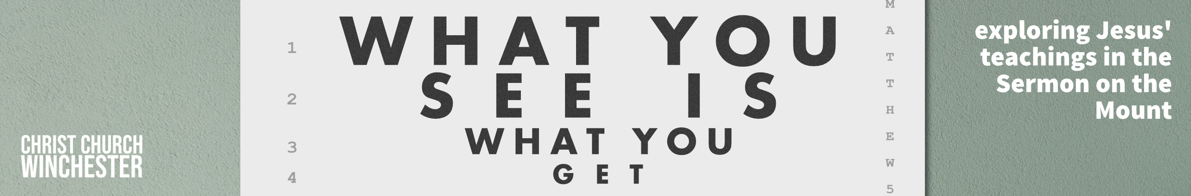
No18 True and False Prophets Matthew 7:15 to 20
This teaching is difficult. The idea that there are people who would teach falsehood in God’s church is not an attractive one. But such people have existed as long as the church. Warnings about false prophets form an important theme in Matthew’s gospel. There are also warnings about such people in the Old Testament (Jer 6:13 to 15 and Ezek 13:1 to 23). All these people attempted to lead God’s people astray by telling them things that were false.
False prophets first seem to be genuine members of God’s flock by their talk and association with the group. They are likened to a wolf that infiltrates and then ravages the flock of sheep it enters (v15).
- How do you spot such a person?
The image of the wolf suggests stealth and deception.
Have any of you any experience of such people working their way into your fellowship?
We are caught on the horns of a dilemma here. We do not want to be people that judge another sister or brother (7:1 to 5) but we don’t want to naively accept someone who would do great damage to the community. Jesus said they will be recognised by their fruit – in this context ‘fruit’ is the product of a person’s essential life. All that a person does reveals who they are.
- We must not over-stereotype here but what kind of personal life should you expect from a true teacher of the gospel and what would you expect to see in the life of a false teacher?
So, in 21st century terms, nobody gets to teach unless we see something of the way they live. Anyone who teaches must be evaluated not only to look at their message but to see if their life conforms to the narrow way that Jesus taught in the previous section (7:13 to 14). Jesus uses one of his ‘obvious’ sayings to which there is only one answer. ‘Do people pick grapes from thorn bushes or figs from thistles?’ Grapes and figs were the staple diet in Palestine – thorn bushes and thistles were hurtful weeds.
- Thorn bushes and weeds choke off nutrients from the soil and fruit bearing plants are harmed. What should be done with people who are teaching in this damaging way?
Who decides what false teaching sounds like?
What happens if false teaching is allowed to continue?
In the Old Testament false prophets encouraged the Israelites to worship foreign Gods (Deut 13:1 to 18). In the New Testament, some churches said you had to be a Jew before you became a Christian. False teaching comes in many and varied forms. One of the 21st century versions is prosperity teaching which is quite common in the affluent west. It says that, if you follow Christ, you should expect to acquire great wealth.
- Why is this teaching false?
What’s the difference between acquiring wealth and being blessed?
What are the dangers of this teaching?
What does it say about the teachers who teach this message?
It is obvious that a vine or tree will only produce fruit that is consistent with its nature. Jesus encourages his disciples to be ‘fruit inspectors’. They are to listen to teachers and think about what is being said and evaluate whether their words are from God. Jesus’ condemnation of false teachers is final and dramatic – cut down the tree and burn it.
- Does this mean we could be spending too much time critically evaluating every sermon rather than listening to what God has to say to us?
On the other hand, should we completely trust everything any preacher says and close off our critical ears?
Sadly, there are some preachers who speak with very little reference to the Bible. It’s also possible to hear a talk which has very little reference to God.
- When we hear that kind of thing should we challenge the preacher?
What kind of talks have you heard which might include false teaching?

PRAY that each person who teaches God’s people
will faithfully teach the message of the Bible
the truth, the whole truth and nothing but the truth

