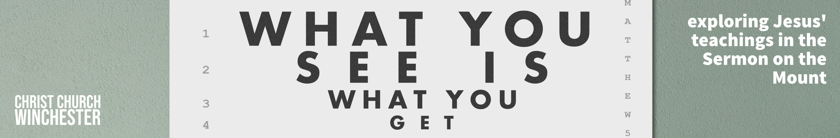
No 2 You are light Matthew 5:14 to 20
Jesus is giving his disciples pictures that will help them understand their place in his kingdom and in their world. Last week we looked at being ‘salt’ – now he tells them they are ‘the light of the world’. This is a continuation of the ‘salt’ metaphor but develops it further.

‘Light’ is an important theme in Scripture normally associated with the removal of darkness as God’s truth is revealed. We even use the phrase ‘seeing the light’ when something we failed to understand becomes clear to us – the fog of our understanding clears and we ‘get it’. Jesus later declares he is ‘the light of the world’ (John 8:12 and 9:5) who has come as light that enlightens all people (John 1:4 to 14) so that those who believe in him will no longer be in darkness (John12:46).

- Talk about the time you saw ‘the light’ of God’s truth.
What was the fog that had to clear before you saw God’s truth clearly?
Are there still ‘fog patches’ that still occur?

Jesus’ life and message of salvation brings light to those in darkness (Matthew 4:15 & 16). His disciples are a living demonstration that it works. The light of God’s truth is not just ‘carried’ by the disciples – they ARE that light. ‘YOU ARE the light of the world’

- This implies that we, as people, are not just carriers of a message.
How does it change our thinking when we realise that the whole of our character and personality is a message to our world?
Is that a pressure or a privilege?

Jesus continues his ‘impossible’ scenarios after ‘can salt lose its flavour?’ No, it can’t. Can a city on a hill be hidden. The city he refers to is probably Jerusalem which, at its peak, is 3000 feet above sea level (the height of Snowdon). The city of Jerusalem was considered to be a light to the world (Isaiah 2:2 to 5, 42:6 & 49:6). But Jesus is teaching in Capernaum in Galilee (70 miles north of Jerusalem) so he could mean a local city. Whichever he means, it remains true that cities on hills cannot be missed.

- This is a real challenge – even if you say you’re very shy and not good at witnessing or talking to people you can’t change the fact that you are the LIGHT of the bit of the world you live in.
Does this change how we see our walk with God?
Can we do things that make THE LIGHT more obvious?

This is a lamp used at the time of Jesus. Oil was poured in the top and a piece of cotton or flax was placed in the spout at the end. This acted as a wick. It did not give off a huge light so, to make it more effective, it was put on a lampstand. Since many Jewish homes were one roomed structures, an elevated lamp would give light to everyone in the house. Lamps were essential for finding your way to enclosed areas during the night and were placed under a bowl only to extinguish the light.

- Our light and life come from God – it is not of our own making. As people see our ‘good works’ they will be pointed to the source of them – God himself.
What is our responsibility here?
Do we sometimes relish the thought of our works being a source of personal glory?
Are we allowed to be proud of our good works?
How easy is it to say ‘all the glory belongs to God’?

In the last four verses of this passage Jesus points to his obvious connection with the Old Testament scriptures. He will be the embodiment of all the Old Testament had been teaching his people. So just as we are to light up our world, Jesus is the light of the whole world as he brings to life the teaching of scripture. Jesus is the fulfilment of the Old Testament – he is what the OT teaching has been looking for.

- Does this challenge our treatment of the Old Testament?
Do we sometimes think the God of the OT is different to the God of the NT?
As the OT causes us some difficult moments of understanding, should we devote more time trying to unravel it?

REFLECTION

At this moment in our nation, perhaps we would do well to reflect how Queen Elizabeth never put her light under a bowl.

Her testimony was loud and clear.

She depended on God and, because of that, she lit up her world.

Pray that each of us may be pleased to be known as a follower of Jesus and that his teaching will be the guiding light of our lives.

.

