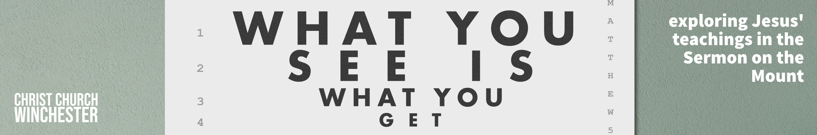
No 20 Wise and foolish builders Matthew 7:24 to 29
We’ve come to the end of Jesus’ wonderful teaching in the sermon on the mount. This the final warning in a series of four that closes the sermon.
- Why not scan through the three chapters (Ch 5 to 7) and talk about teaching that has been a
- Blessing or encouragement
- Challenge
- Surprise
- New discovery
- Life changer
Jesus’ prelude to this last warning expresses the whole thrust of what he has been teaching. We are to listen to the words of Jesus and put them into practice. His sermon is not clever words – it is a blueprint for how we should live. And it is for ‘everyone’ (v24). Just as it was for those who heard it in the first century so it is our standing orders for 21st century life.
- What are the elements of the sermon that challenge the prevailing culture of the day?
What are the aspects of the sermon that are ignored today?
As an example, you might like to look back at Ch 7: 1 to 6 and ask how ‘not judging’ is ignored in today’s world. Are we too eager to judge others – what are the consequences of that?
You can apply that process to many of the issues Jesus speaks about?
The context of wise and foolish building would have seemed ridiculous to a 1st century listener. We think of ‘sand’ as something on a beach which sometimes stays dry. Jesus is referring to a wadi – a valley cut by flash floods coming off the Judean hills. It’s dry most of the year but when you get one of your 14 days of rain per year (recorded near the Dead Sea) it becomes a raging torrent. Why build a house where you know it’s going to be hit by a deluge?
- This would seem to be senseless building. But are we guilty of building our lives on things that we know could be swamped by worldly pressures?
Do we rely on wealth, status or experience all of which can let us down rather than on God’s word to us (v24)?
Whether you relate this to the geography of the Dead Sea or the Sea of Galilee, the locals all knew that winter rain came and flooded what appeared to be dry ground for most of the year. Sometimes you would need to dig down 10 feet to get to bed rock but recent excavations have shown that’s exactly what people did. The style of leadership and teaching provided by the religious establishment of the time was shallow and made few demands on how you should live day by day
- What does Jesus say about the foundations we should lay down in our lives/ They are clearly meant to be strong and lasting.
We are to base our lives on the bedrock of listening to Jesus’ words and putting them into practice.
Give some examples of where you have heard Jesus’ teaching and changed your lifestyle because of his words.
Are there some issues you need to address where you are not following Jesus’ teaching?
The wise person shows that s(he) has viewed the shifting sands of life’s teaching today and understands that Jesus is the only secure source of truth to be had.
- What does it mean to base our lives on God’s word?
Should we base all our life decisions on God’s word?
What do we do if we can’t get a direct answer to the question we are asking?
The words Matthew uses to round off this sermon are very telling. Although Jesus seems to have intended the major audience to be his disciples, the crowds have been listening in. They have heard him teach and they were impressed. We know from other texts that the religious authorities found Jesus’ teaching rather toxic. But the crowds lapped it up.
- Should we take Jesus’ teaching more seriously?
Do we see it as being vital to our lives?
Do we think of it as coming from God who makes demands on us and the way we live?
Do we give it enough authority?

