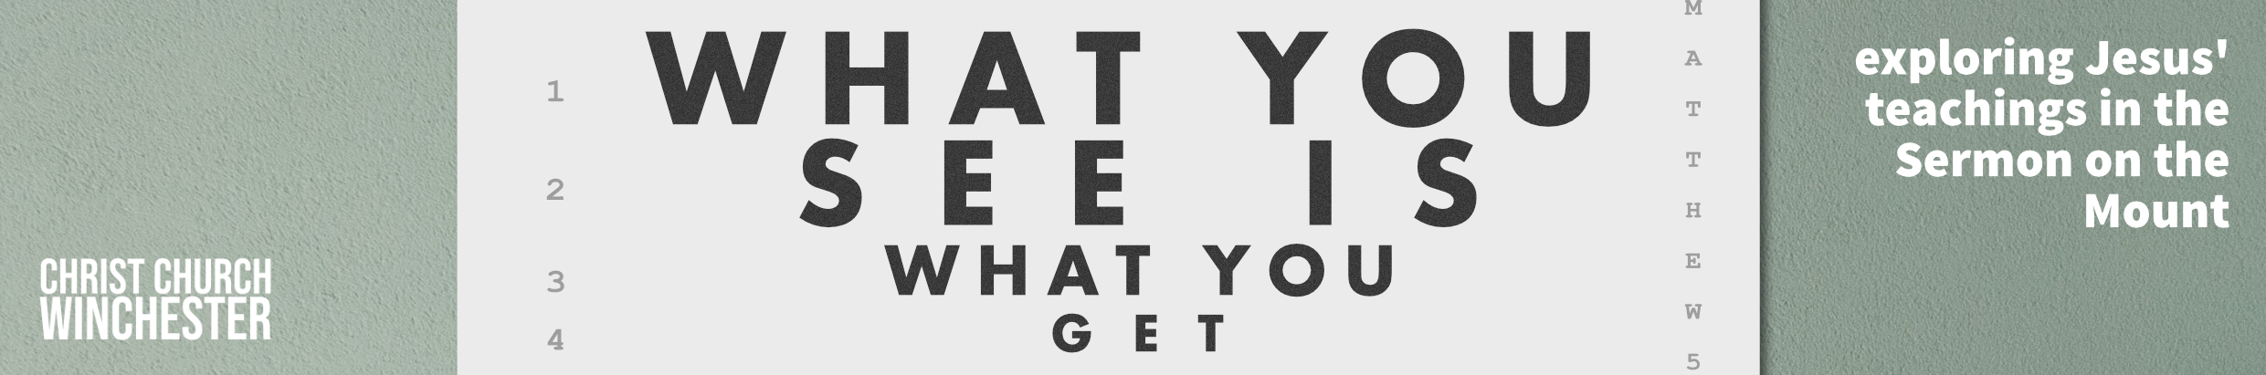
No 6 What they see should be who I am Matthew 5:33 to 37
Jesus is giving his disciples teaching that will help them understand their place in his kingdom and in their world. He has used the idea of antithesis to make his point. This section begins with a summary of ‘oath’ passages (Exod 20:7, Lev 19:12, Num 30:2 and Deut 23:21 to 23. In the OT, God often guaranteed the fulfilment of his promises with an oath (Gen 9:9 to 17).

In the same way the OT permitted a person to swear by the name of God to support an important promise or affirmation. An oath enabled a person to remain faithful to any commitment they may have made. The law required that a person must be true to their word in keeping what they had promised.

- How important is it to keep our promises?
Has our society become too loose in keeping promises both as individuals and in our institutions?
Where do you see the erosion of promise keeping?
What effect does this have on our corporate life?

Some people in Jesus’ day said only oaths made to God were binding. If you swore by ‘heaven’ or ‘earth’ or by ‘Jerusalem’ they weren’t being serious about their oath and therefore the oath wasn’t binding. The increasing tendency to find loopholes in an oath led to their devaluation. Some people warned against making oaths about anything.

- As oaths had ceased to have much currency in the 1st century, what is our 21st century equivalent?
With ‘fake news’ being a current phrase, how easy is it for people to drift into spreading falsehood and not to have a conscience about it.
Should we challenge leaders who have clearly not kept their word?

Jesus goes right to the heart of what the law was trying to achieve when he says you shouldn’t swear at all. What we speak with our mouths comes from our hearts. A dependable heart will speak truth – a phrase like ‘yes, I swear’ doesn’t mean much.

- How do we respond to people who we know are not speaking the truth?
Should we challenge them if we suspect their words are untrue?
If you feel able to, talk about times where lying has been hurtful to you?

Jesus said a simple ‘yes’ or ‘no’ was all that was needed. When each person’s word is straight and honest we are liberated to trust each other more freely. When a person’s word or handshake cannot be trusted then we have to bring in all kinds of legal safeguards which complicate daily life.

- Sometimes we can become victims of malicious people who spread lies about us. They may harm our reputation or destroy our character.
How do we respond to that kind of behaviour?
Is it ever right to ignore it?
Should we always challenge it?

It is difficult living in a world where you feel you can’t trust anybody to speak the truth? How do we deal with politicians who have clearly drifted into untruth.
- Should we ever support a leader who has told lies?
Is exaggeration lying?
Is telling only half the story a form of hiding the truth and therefore lying?
Is it sometimes more caring not to tell someone the whole truth about a situation?
(e.g. someone you know has been killed in a car accident. You know the full details of the accident but all you tell someone is that they have been killed)

We all know people whose word cannot be trusted. Perhaps we have been guilty ourselves.

- What difference would it make to our society if everybody’s word could be trusted?

REFLECTION

There are parts of our national life where, recently, the truth has been in short supply

It would be good to take some time to pray for the leaders of our city and country. Ask God to help them to be those who speak truth in measured and accurate ways in the statements they make to us.

